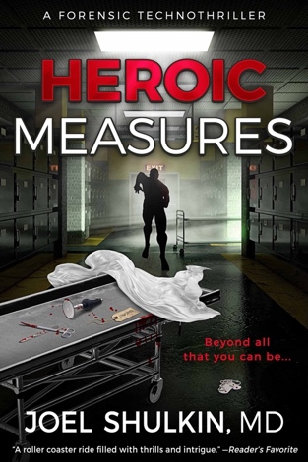
For immediate release

Zero Dark Publications announces the dawn of a new
fiction genre with the publication of the forensic
technothriller HEROIC MEASURES
ST PETERSBURG, FL April 21, 2024

Thriller author Joel Shulkin, MD, author of the award-nominated medical thrillers Adverse Effects and Toxic Effects, will publish a new type of thriller on September 17, 2024. Billed as a “forensic technothiller”, the book HEROIC MEASURES seamlessly blends forensic medicine with military, science-fiction, and superhero themes into a fast-paced, nail-biting thriller. Shulkin draws upon his experience as a doctor, veteran, and comic book fan to craft an original story that blurs the lines between thriller subgenera.

When a cadaver wakes up on the autopsy table, medical examiner Lt Col Stephen Englehart uncovers a plot to turn soldiers into super-weapons--a plan that has gone horribly wrong. Stephen’s search for answers pits him against superior officers who will stop at nothing to cover up the truth. But when Stephen discovers his sister, a Green Beret, is the next experiment, he must risk his career and his life to save her.

“A powder-keg combination of military, medical, and techno thriller. Buckle in for a wild and suspenseful ride.” –Meg Gardiner, #1 New York Times bestselling author
“A high-octane blend of action and intrigue. . .that’s a delight to read from beginning to end, Heroic Measures is an unreservedly recommended Golden Quill read!” – Book Viral Reviews
“A roller coaster ride filled with thrills and intrigue.” – Reader’s Favorite

Formats: E-book (ASIN B0CVBFVJZN) at Amazon, Kobo, Google Play, iBooks, and B&N
Paperback (ISBN 979-8-9900188-1-5) and Hardcover (ISBN 979-8-9900188-0-8) at Ingram
Audiobook at Audible

Detailed book/information, bio, photos, trailers, and other materials at https://www.authorjoelshulkin.com/press-kit/
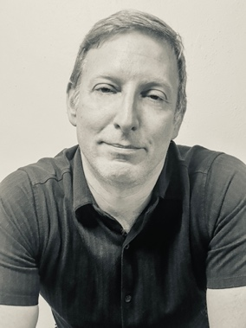
Joel Shulkin, MD is the author of Adverse Effects and Toxic Effects,
the first two novels in the Memory Thieves series, and he has penned award-winning short stories and poetry. A developmental-behavioral pediatrician and United States Air Force veteran with a master’s in
public health, Joel lives in Florida with his wife, two daughters, and two puppies.

